1. **HTTPS cloning using git**

**STEP 1:** Open git from the directory you want to clone

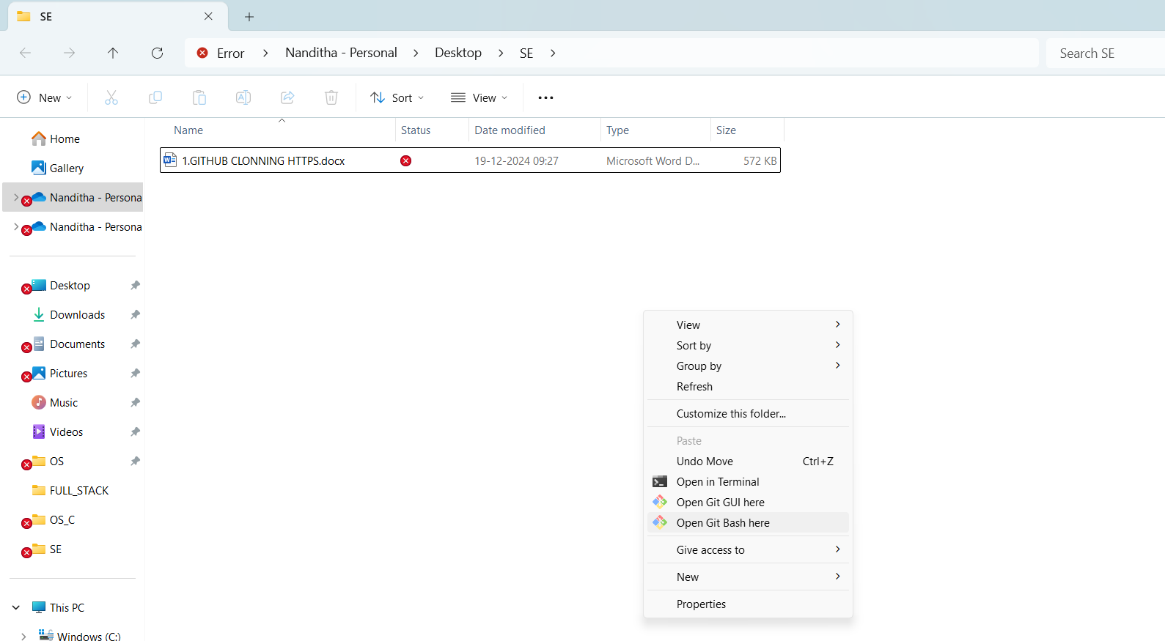



**STEP 2:** Copy https link from the repository

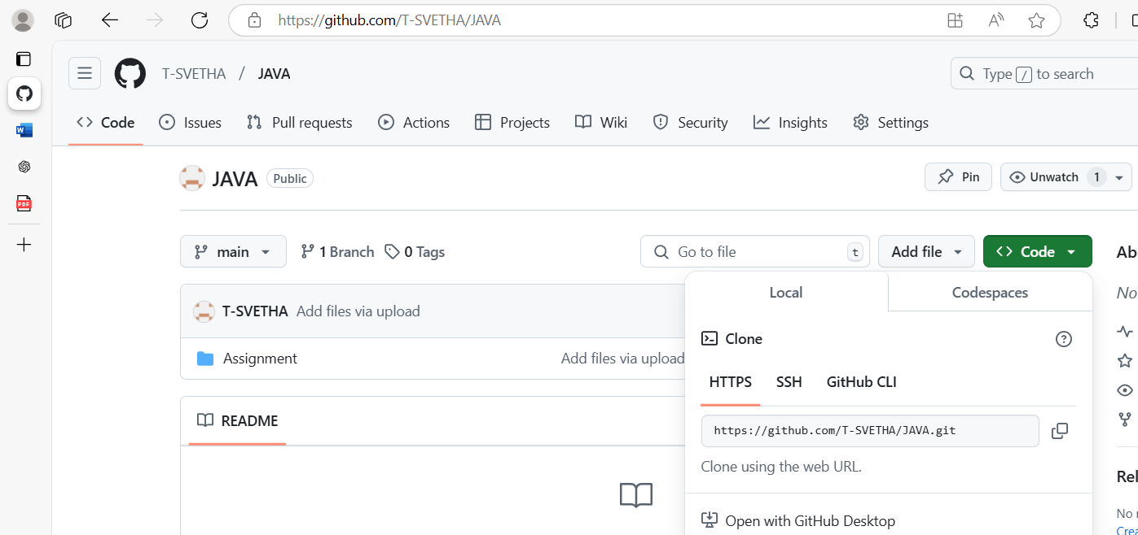



**STEP 3:** Execute in git

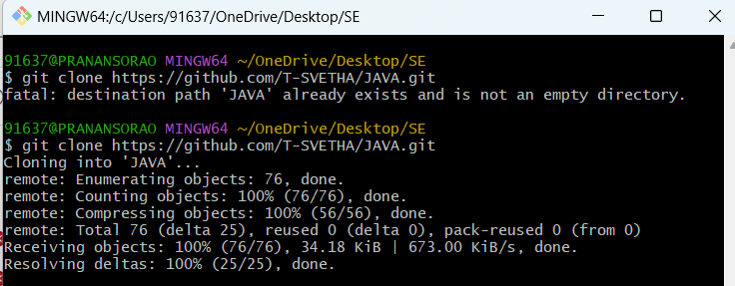



**STEP 4:** cloning is done

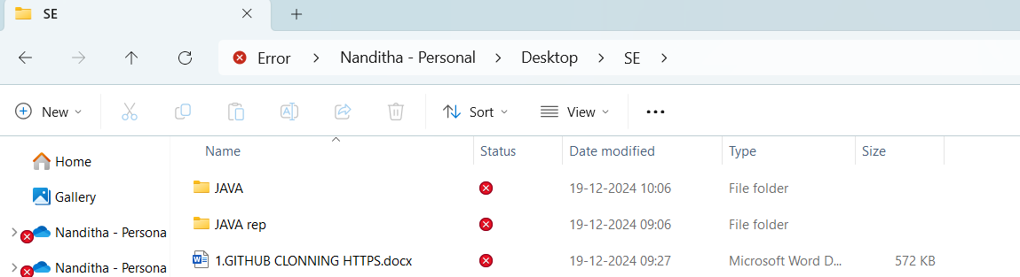



**2. GitHub CLI using git**

**STEP 1:** Open git from the directory you want to clone





**STEP 2:** authenticate login to the github CLI using the commands in git (winpty gh auth login)

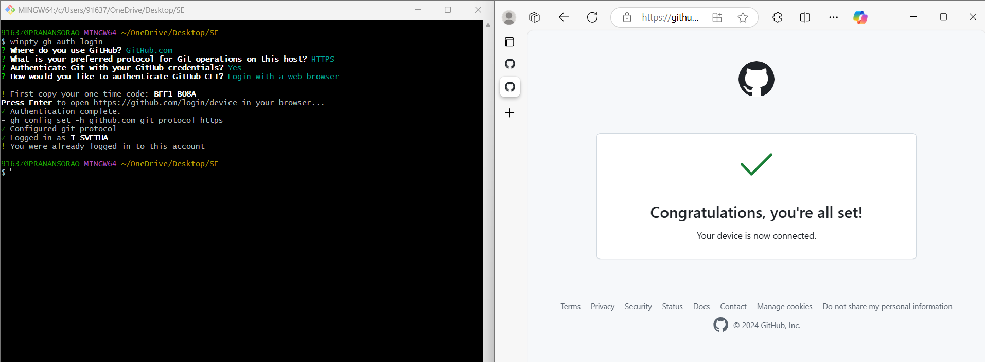



**STEP 3**: Copy GITHUB CLI link from code in repository

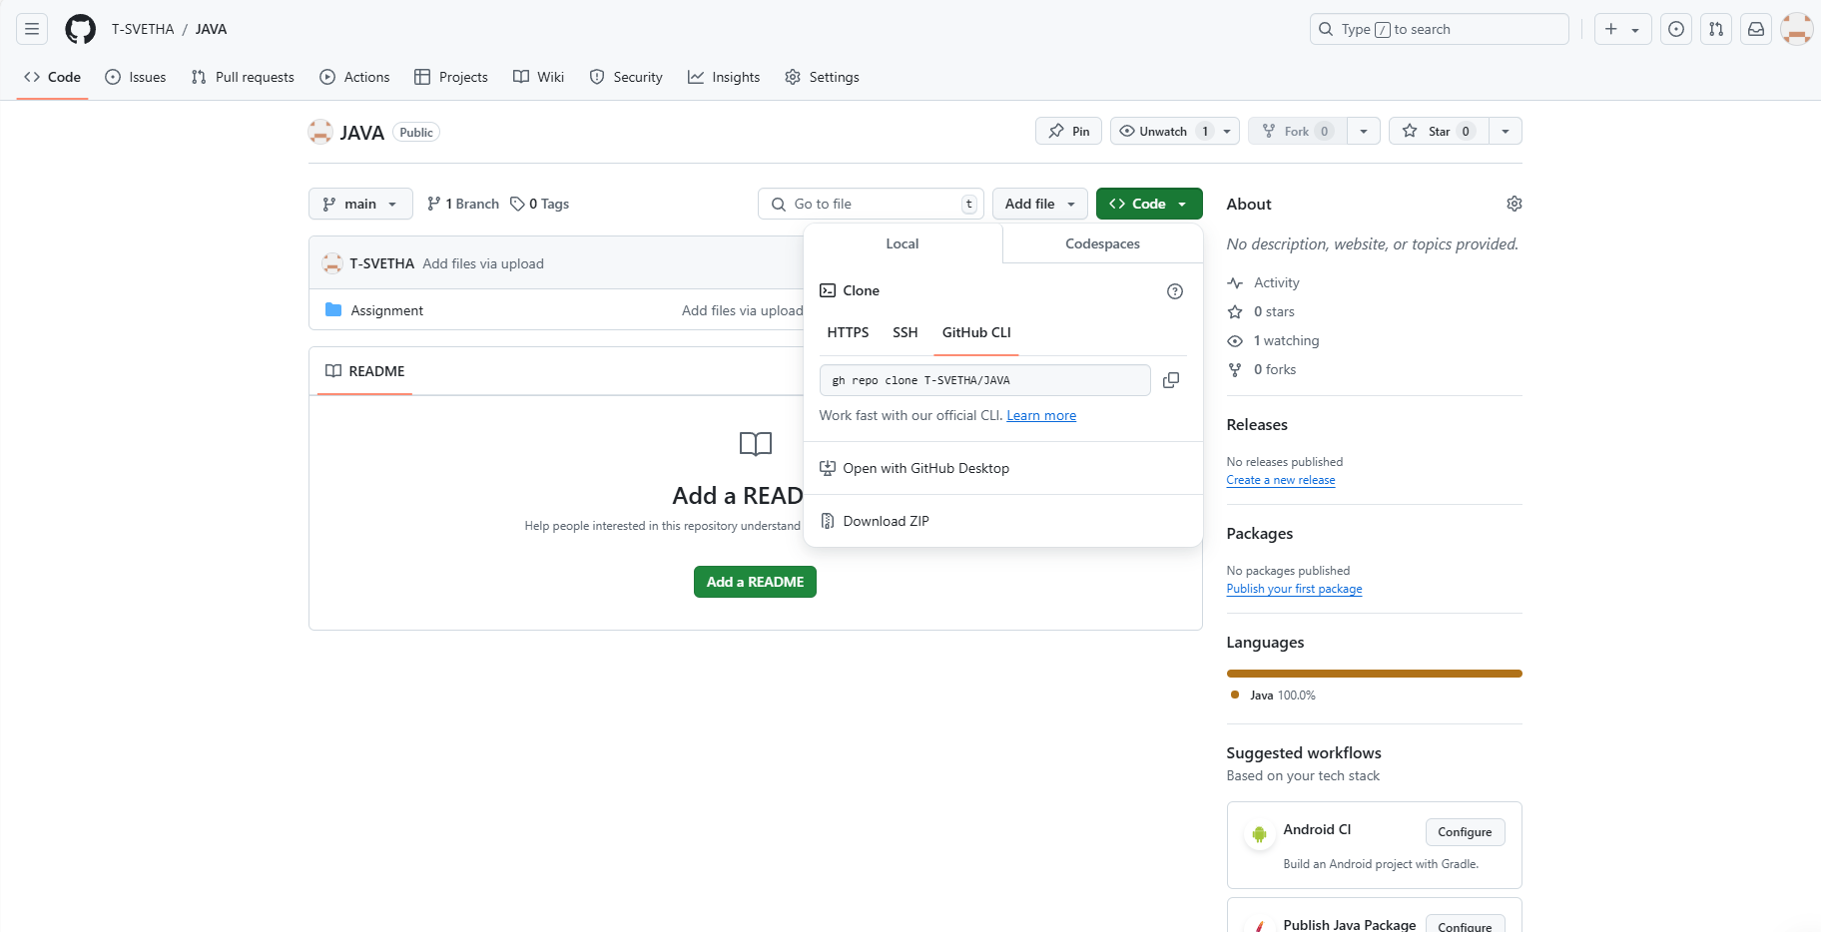



**STEP 4**: Execute the command in git

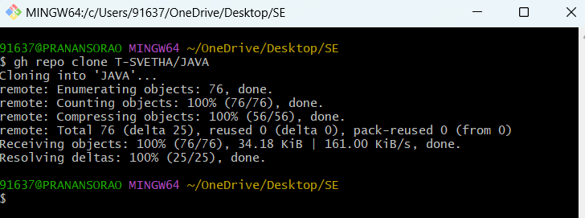



**STEP 5**: Clonning is done into the directory

